**Document Understanding - Invoice Data Extraction**

**Omprakash Kumawat,** Department of Computer Science and Engineering, JK Lakshmipat University, Jaipur, India.

omprakash.kumawat@jklu.edu.in

Submitted to: - Mr. Santosh Kumar Verma

santosh.verma@jklu.edu.in

**Abstract:** We will extract data (invoice number, date, total, etc.) from a folder of invoices to an Excel file in this use case. We will also talk about the Present Validation Station, where users can verify the results in an attended robot with help of Optical character recognition.

**Keywords:** *OCR, efficiency, coordinates, RPA***.**

**Introduction:**

We have multiple invoices in different formats that we want to automatically extract data from. The game plan is to use the Document Understanding package in UiPath. We are using Digitize Document to read the invoice into a format and can work within UiPath. In this use case, we use the tesseract OCR. Here we must classify, that is, sort the input (here are our invoices, but we could have documents of other types). A keyword-based classifier is used. Remember to create an empty JSON. For attended use, we can use a validation step, where the user can validate the extracted data. The data will be written to Microsoft Excel.

**Description of the Work:**

The Framework of Application flow is shown below:

**Figure 1:** DFD diagram of the use case titled “Document Understanding - Invoice Data Extraction” is shown in figure1where the entire process is divided into Six segments.

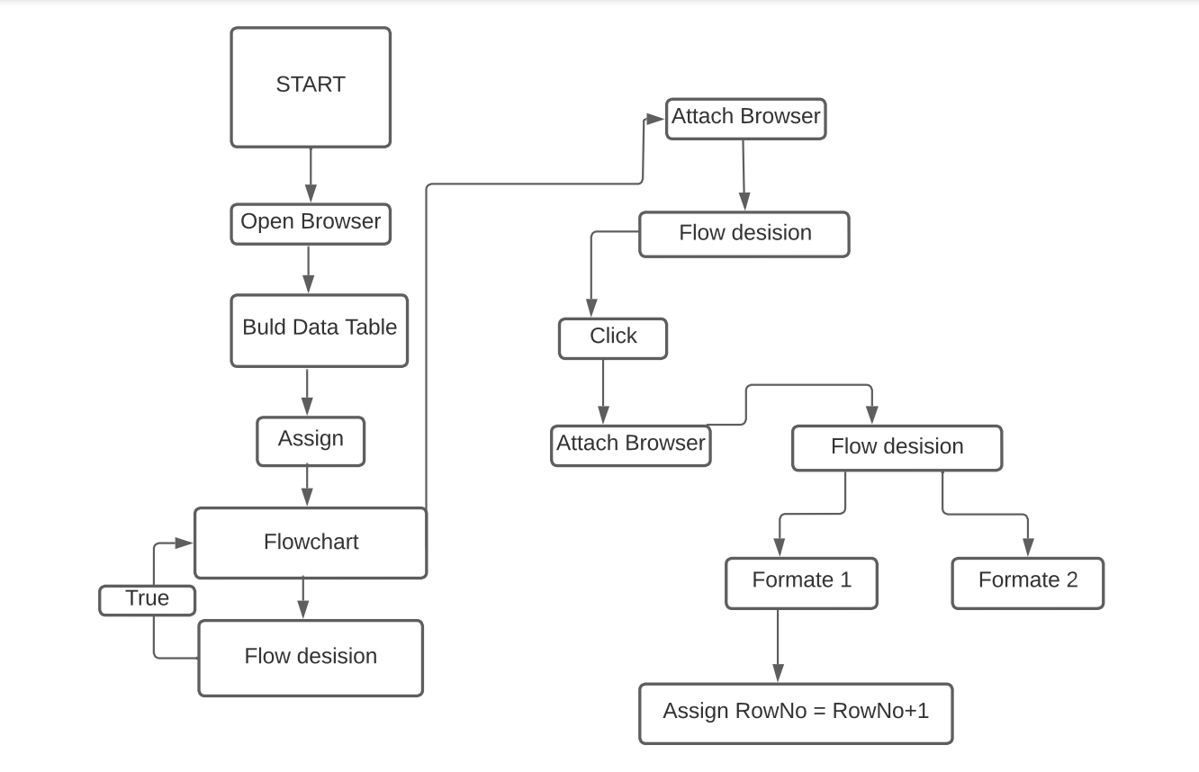

*Fig 1: DFD of use case*

**Figure 2:** Flowchart diagram of the use case titled “**Invoice Automation**” is shown in figure1where the entire process is divided into three segments.

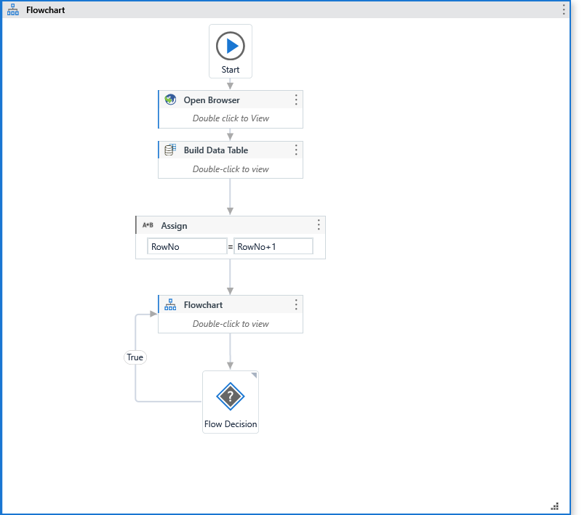

*Fig 2: Flowchart/activity diagram of use case*

**Figure 3:** Figure 2 Shows the first section which is Browser opening section is initiated. Where browser input activity is called.

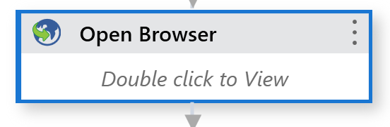

*Fig 3: opening the browser.*

*.*

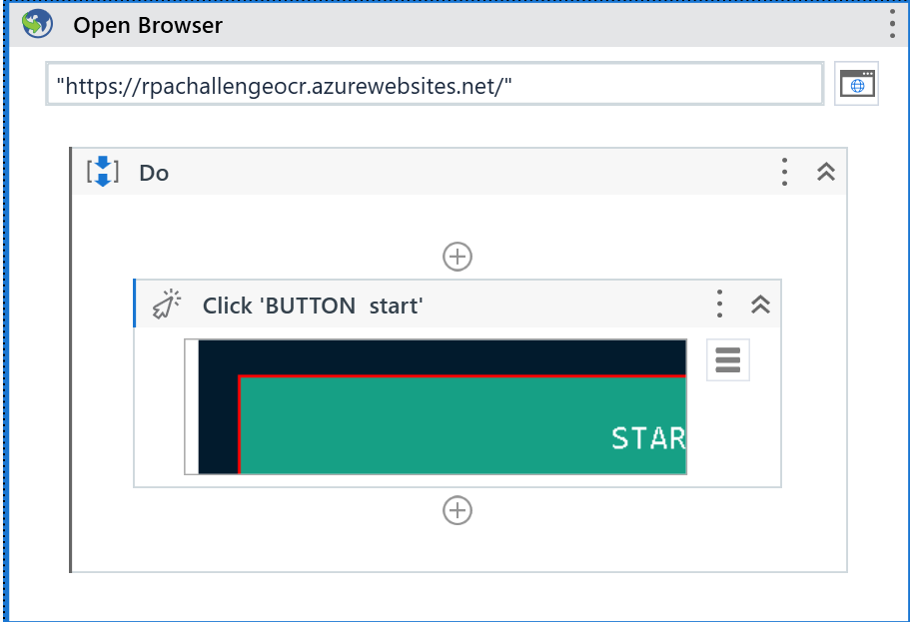

**Figure 4** Creating the Data table for storing the data.

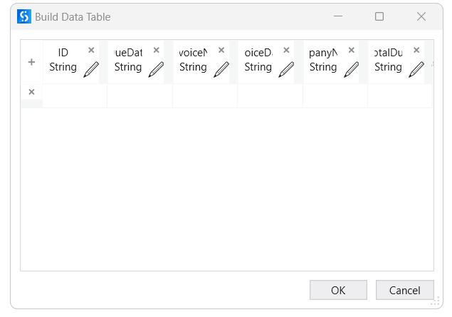

*Fig 4: Selecting image File for automation.*

**Figure 5: -**For iterating over the invoices we need to assign a variable to store the counter value

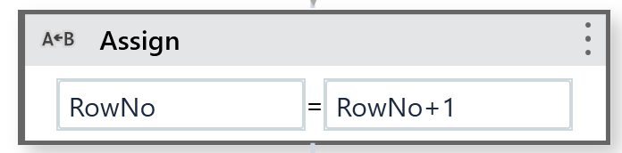

*Fig 5: Assigning the counter values.*

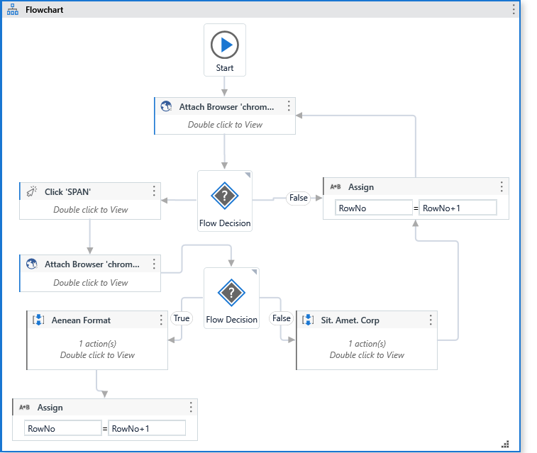**Figure 6:** Figure 6 shows the process of decision flow. First open browser activity then click the start button window then click zoom in button.

**Figure 7&8:** These figure shows the two different types of invoice extraction type from which with help of OCR we will be extraction the data.

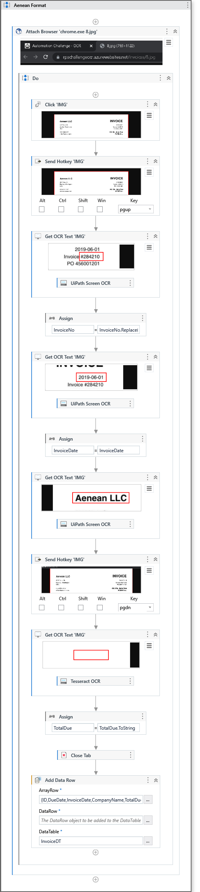

*Fig 7: Anenan company invoice formate*

*Fig 8: St. Amet corp format*

**Figure 8.** From here we will discuss the steps for extracting the components of both types of formats.

1. First, we will attach the browser to identify.

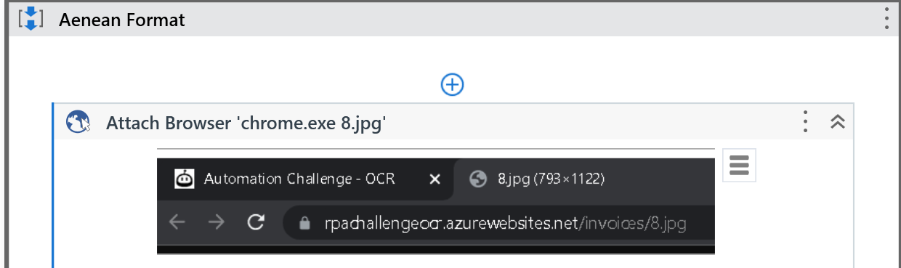

1. **The next step is to click on the image of the Aenean format.**

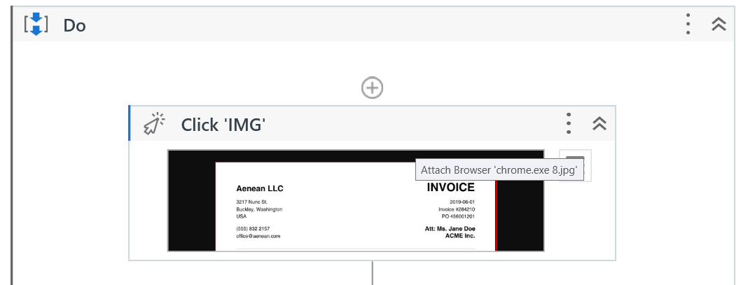

1. **Using the hot key to scroll the page down.**

1. **Using Get OCR text which take image as input and convert that into text. In this step we will extract the invoice number.**

1. **Assigning the invoice number to a variable “InvoiceNo”.**

1. **Again, using Get OCR activity to extract the date and assign it to the variable InvoiceDate.**

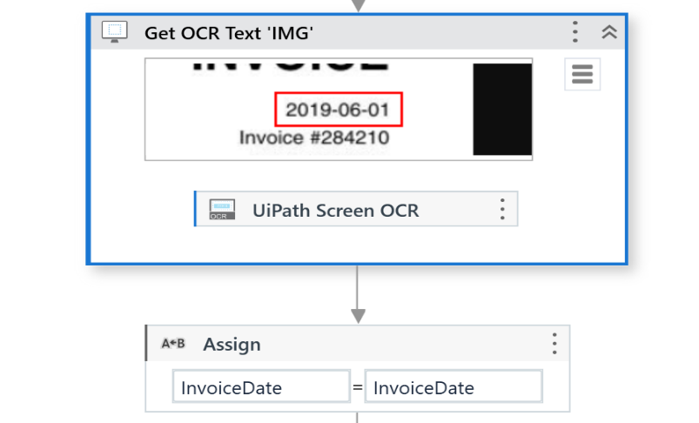

1. **For extraction company same step as above.**

1. **Using the send hotkey activity to scroll the page down.**

1. **Extracting of total due amount using get OCR activity we will extract the due amount and store it in the variable TotalDue.**

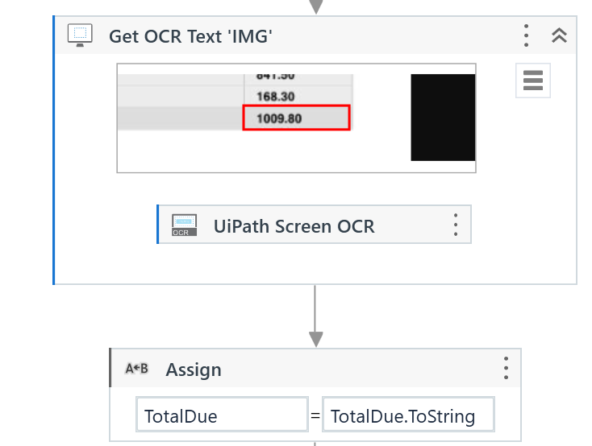

1. **The next step is to close the tab using the close tab activity.**

1. **Now we will store all the extracted in the table using the add the Data Row activity.**

1. **Increasing the counter, the RowNo by adding one into it for iterating it to next invoice.**

1. **Writing all the data into excel with providing link of the excel data.**

1. **The same steps we will follow for the other format of the invoice.** “**Sit. Amet. Corp**”

**Figure 9** Increasing the rowNo the counter to plus one to move to next invoice.

**Figure 9:**  Adding extracted values in excel sheet.

**Conclusion:**

In conclusion, the use of RPA technology in conjunction with UiPath, Visual Studio, OCR, and Excel has proven to be a highly effective solution for automating the invoice extraction process. By leveraging OCR technology, the RPA software can quickly and accurately scan invoice images and extract relevant data. This data can then be stored in a structured format in Excel, making it easy to analyze and utilize. Overall, this approach not only saves time and reduces errors, but it also enables organizations to improve their overall efficiency and productivity. As technology continues to evolve, RPA will play an increasingly important role in streamlining business processes and improving organizational performance.

**Future Work:**

There are several future scope and opportunities that can be explored in the above situation of using RPA UiPath, Visual Studio, OCR, and Excel for invoice extraction, including:

* Integration with machine learning: The use of machine learning algorithms can enhance the accuracy of OCR technology in recognizing and extracting invoice data. Incorporating machine learning models into RPA solutions can enable the system to learn from past experiences and improve its accuracy over time.
* Automation of end-to-end invoice processing: Beyond invoice extraction, RPA can be used to automate the entire invoice processing workflow, from invoice receipt to payment processing. This can result in significant time and cost savings for organizations, as well as improved accuracy and compliance.
* Integration with other enterprise systems: RPA solutions can be integrated with other enterprise systems such as ERP, CRM, and document management systems to enable seamless data flow and process automation. This can further enhance efficiency and reduce manual errors in business processes.
* Cognitive automation: The use of cognitive automation technologies such as natural language processing (NLP) and sentiment analysis can enable RPA systems to process unstructured data and understand the context of invoice-related data. This can further enhance accuracy and enable organizations to extract insights from invoice data.

**References**

* [**https://docs.uipath.com/studio/standalone/2022.10/user-guide/ocr-activities**](https://docs.uipath.com/studio/standalone/2022.10/user-guide/ocr-activities)
* [**https://docs.uipath.com/studio/standalone/2022.10/user-guide/example-of-using-ocr-and-image-automation**](https://docs.uipath.com/studio/standalone/2022.10/user-guide/example-of-using-ocr-and-image-automation)
* [**https://www.oreilly.com/library/view/learning-robotic-process/9781788470940/aff915fa-b810-4a08-a83d-403922bfeef2.xhtml**](https://www.oreilly.com/library/view/learning-robotic-process/9781788470940/aff915fa-b810-4a08-a83d-403922bfeef2.xhtml)